**4. Introduction to the Schrodinger Equation**

**Preamble**

A review of Key experiments showed that a Wave – Particle Duality concept needed to be incorporated into a **new equation of motion** to have the appropriate framework for understanding phenomena at the **atomic level**.

**CP** – Newton’s equations of motion for a particle do not work in this atomic domain.

**Needed was a wave/particle equation relevant to the atomic regime which does work.**

**Erwin Schrodinger** was the first person to formulate successfully a quantum mechanical wave equation though other approaches also were being developed at that time.

– His approach uses several new concepts: operators, eigenfunctions, eigenvalues, wave functions, etc. with the idea being that **eigenvalues** are equivalent to **“observables”** (i.e., to measured results such as energy) for particular physical quantities and that a system’s **wavefunction** can be used to find out **everything** about the system.

We will find that in applying Quantum Mechanics (QM), we start with an equation for the total energy of the system (when the equation for energy is written in a certain way) and use some rules to obtain the QM **wave equation** (remembering that now we need to think of all things as having a **wavelike character** **as well as** a **particle-like character**). An illustration:

– In order to demonstrate the particle like character requirement, we start by writing the equation for the total energy of a system as

E = K.E. + P.E. (i.e., sum of the Kinetic Energy and the Potential Energy)

i.e., E = ½ m v2 + V(x) {where V(x) will vary with the system being considered}

or E = p2/(2m) + V(x) (because p = mv)

or 

– The wavelike character of a system is indicated by its **wavelength** and we have seen how we can get this from a knowledge of p (recall: λ = h/p → p = h/ λ from De Broglie), hence



– This is not the “wave equation” yet, however.

**“Photon” Note:** Relative to the above definition for p, **photons** are somewhat unusual particles:

– **Photons** have **energy**, E = hν (where h = 6.62607015 × 10–34 J s; [exact])

– **Photons** have **zero rest mass** but in traveling at the speed of light, c, have **a relativistic mass** that can be determined using the equation E = mc2

From these relationships, have for **photons**, hν = mc2 → 

**{Please determine the [h/(cλ)] factor NOW for λ = 600 nm. Answer:** 3.683698429×10−36 kg.}

**[Fall 2021]**

**CP and QM descriptions should merge but when? I.e., when is QM’ics required?**

* **CP and QM are not *two competing ways*** to describe the world around us; each is useful but in a different realm. QM **should merge seamlessly** into CP and vice versa.
* Essentially **two criteria** tell us whether QM provides the appropriate description of an atomic or molecular systems or whether CP provides an adequate description:
  + (1) **Magnitude of the wavelength** relative to the dimensions of the system and
  + (2) Degree to which the allowed energies form a **continuous energy spectrum**.
* **(1) λ:** Put numbers into the de Broglie relation (λ = h/p), to determine the wave characteristic for a system.
  + E.g., the wavelength, λ of a room temperature H2 molecule traveling at root mean square speed (3kBT/m)1/2 is ~1 Å but the λ of a baseball bat being swung is ~10–34 m.
  + So, in interacting with matter, the H2 molecule could only be diffracted (→ wavelike character) if it encounters an opening with dimensions comparable to its wavelength (such as in a crystalline solid as found in the Davisson-Germer experiment).
  + But for the baseball bat, we could not see diffraction and hence its wavelike character because we’d have to construct an opening ~10-34 m in width!
* **(2) Energy:** Whether or not we need to use a QM description of a system depends on the energy spectrum of the respective feature of a system (e.g., translational energy vs. vibrational energy).
  + **If all values of energy are allowed for that feature of the system then CP applies** (e.g., translational energy and hence for the pressure for H2 in a glass cylinder),
  + **BUT** **if only certain energies are allowed for a particular feature of a system (i.e., that feature has a discrete energy spectrum), QM is needed to describe that feature of the system** (e.g., electronic energy of H2 molecule in light absorption).
  + For an ideal atomic, monotonic gas, the only energy is in the form of translational energy. At equilibrium, not all of the atoms have the same translational energy. In fact, the atoms have a range of energies and the average energy is  where kB (the Boltzmann constant = 1.380649 × 10–23 J K–1) = R/NA
  + If we are looking to relate the number of atoms nj of energy εj to the number of atoms ni with energy εi, we need to use the Boltzmann distribution to describe the system:
    - where each **g** is the **degeneracy** of an energy level **ε** and represents the number of ways an atom can have energy **ε**. **gi** is the number of ways an atom can have energy **εi** in the interval ε – Δε < εi < ε + Δε and it can depend on the energy (e.g., εi = ½ mvi2 and vi2 = vix2 + viy2 + viz2 and the resultant velocity value will depend on the temperature so there are a number of ways of arriving at the same εi value).
* Now kBT is approximately the average energy of the atom at T:
  + - * **If kBT is small cf. spacing between the allowed levels εi - εj**  i.e., if (), **QM is required** whereas
      * **If kBT ≈ ΔE** or is much larger than the energy spacing, **CP will suffice**.
* It is possible to have system where a continuous transition between a CP and QM description can be observed: e.g., a large increase in T could cause a system that exhibited QM’al behavior at low T to exhibit CP’al behavior at high T.

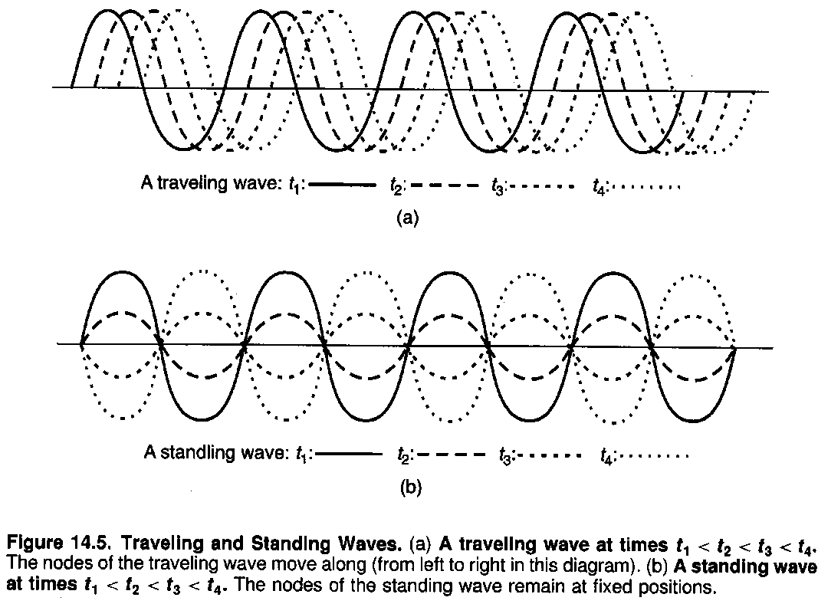**Classical Waves**

A **wave** consists of an oscillating displacement (e.g., sound waves caused by vibrating strings in a musical instrument).

Distance from one crest to the next is the **wavelength (λ)** and the **period** **(T)** of the wave is how long it takes to complete 1 cycle. Reciprocal of the **period** is the **frequency (ν)**. A location where the displacement is always 0 is called a **node**.

A wave is **inherently delocalized** (it does not “exist” at a single point in space).

As illustrated in the diagram here, there are **2 principal types of waves** – a **traveling wave** which “moves along” like waves on the surface of a lake and a **standing wave** such as the vibration of a string in a guitar – it does not propagate and has **stationary nodes**.

**Wave function and Wave equation for classic cases**

The **velocity** and **frequency** of a wave governs (a) the variation in **amplitude** of a wave with **time** at a fixed point and (b) the variation in **amplitude** with **distance** at a fixed time.

* These variations in displacement can be described mathematically by a **wave function** Ψ(x,t) (“Psi”) which describes how the **amplitude** of the displacement varies with **time** (t) and with **distance** (x) where x is measured along the direction of propagation.
* E.g., For a sinusoidal wave of wavelength λ, frequency ν = 1/T where T is the period of the wave, velocity v = λ ν, and with peak to peak amplitude A, the wave equation is

= the **wave function**

where we have chosen our zero of time and distance such that Ψ(0,0) = 0.

* Note that the wave amplitude = 0 when the sine term is zero and this occurs when

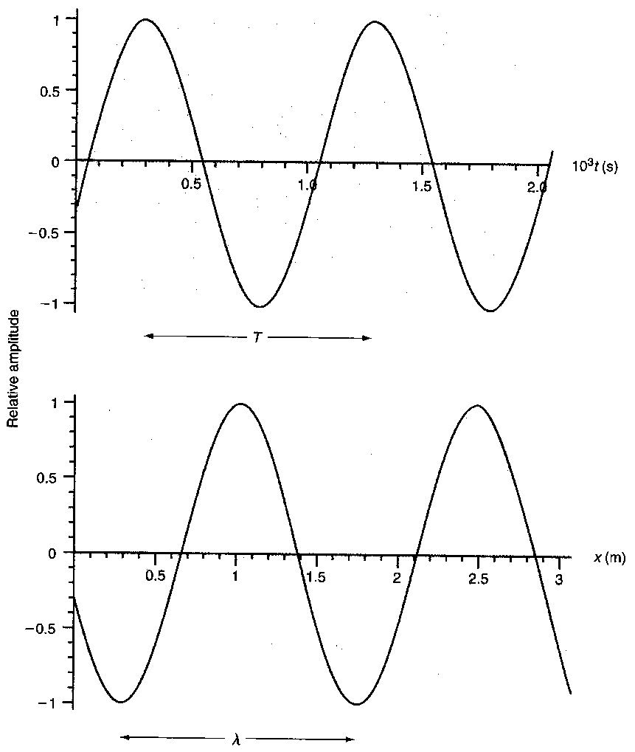 where n is an integer. Solving for x in this case gives us the **positions** of the **nodes** in the wave (i.e., the places where the wave has zero amplitude), i.e., where .

* It is convenient to combine some of the constants and variables in the wave function:

 where

**k = 2π/λ** is called the **wave vector** and **ω** (“omega”) **= 2πν** is called the **angular velocity**.

(k in this context is NOT the Boltzmann Constant!)

* Value for Ψ(x,t) is the same when the argument in the sine term changes by 2π.
* The choice of a zero in position or time is arbitrary: we could add an arbitrary constant φ to the argument and the wave function would still have the same form:

argument



This is appropriate when ψ (0,0) ≠ 0 (as for our diagrams on p. 4). The **argument** of the Sin term is called the **phase** and a change in the initial phase (i.e., of the argument when x and t = 0, i.e., in the constant φ), simply shifts the wave function.

* When 2 or more waves are in the same region of space, their time-dependent amplitudes add together and the waves are said to **interfere** with each other.
  + This **interference** can be **constructive interference** where the sum of the waves leads to overall enhancement or be **destructive interference** if the wave amplitudes are opposite in sign and equal in amplitude.
  + Interference can also result in the formation of **spatially fixed nodes** where the amplitude at that place is zero at all times.
* E.g., consider the interference of 2 waves of the same frequency and amplitude moving in opposite directions. The resultant wave function can be written as

 .

By applying the trigonometric identity

Sin (α ± β) = Sinα Cosβ ± Cosα Sinβ

twice, we can simplify this equation to

.

The resulting function of x and t is now a **product** of 2 functions each of which **depends on only one variable, x or t**.

When we plot this function (next page), we find the positions of the nodes are always the same: i.e., the resulting wave is a **standing wave** (to be distinguished from a **traveling wave)** where the whole wave (including the nodes) propagate at the same velocity.

* **Standing waves** arise if the space in which the waves propagate is **bounded** (e.g., waves on a guitar string, or waves in a standing-wave laser cavity where the light propagation is limited by the end mirrors – the high reflector and the output coupler).
* **Standing waves** are important **in QM** because they **represent** **stationary states** which are states of the system where the **measurable properties of the system do not change with time**.
* A **standing wave’s** progression is illustrated on the next page.

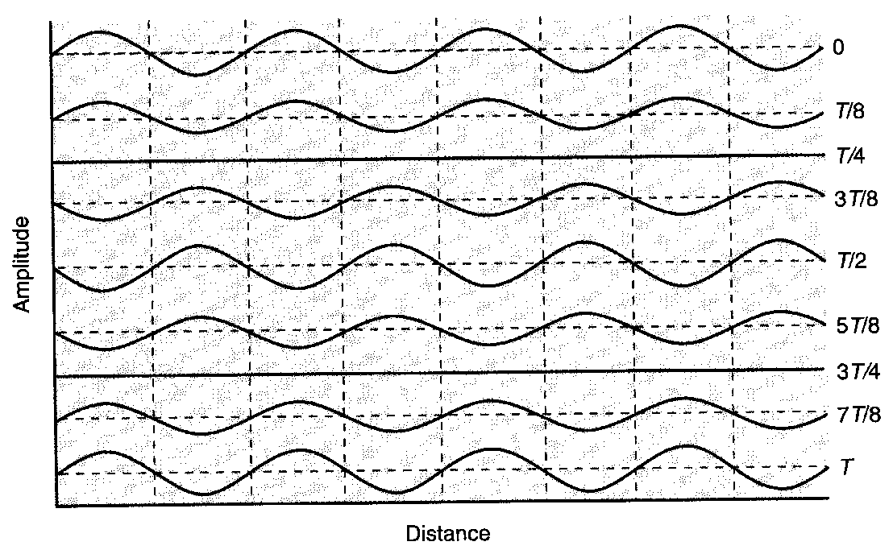

* Generally, for wave propagation in a medium for which all frequencies propagate with the same velocity, we can write which is the **classical non-dispersive wave equation**; here v = velocity at which the wave propagates.
* Note that the traveling wave we encountered above [] is a solution of the non-dispersive wave equation when v = ω/k.

**Wave functions written as Complex Numbers**

A wave traveling in the positive x direction can be written as



where φ′ = φ - π.

By use of **Euler’s formula ** , this equation can be written more conveniently as

 where for this case we have denoted (via “Re”) that we are only considering the Real part of the complex function.

However, even when working with CP wave functions, it is less cumbersome to work with the whole complex wave function and to extract the real part as we need to do so.

That is, we use

.

Operations such as adding 2 waves, differentiation, and integration are much simpler when working with the complete complex notation.

Note that **Quantum Mechanical** **wave functions** (and we are not working with them yet), can have **complex amplitudes**.

**Revision: Complex Numbers**

A **complex number** z can be written as a + *i* b where a and b are real and *i* = .

By use of the complex plane where the a (“x”)-component is the real part and the b (“y”)-component is the imaginary part, a complex number corresponds to a point (a, b) in the complex plane. The quantity *i* b is said to be pure imaginary if b is a real number.

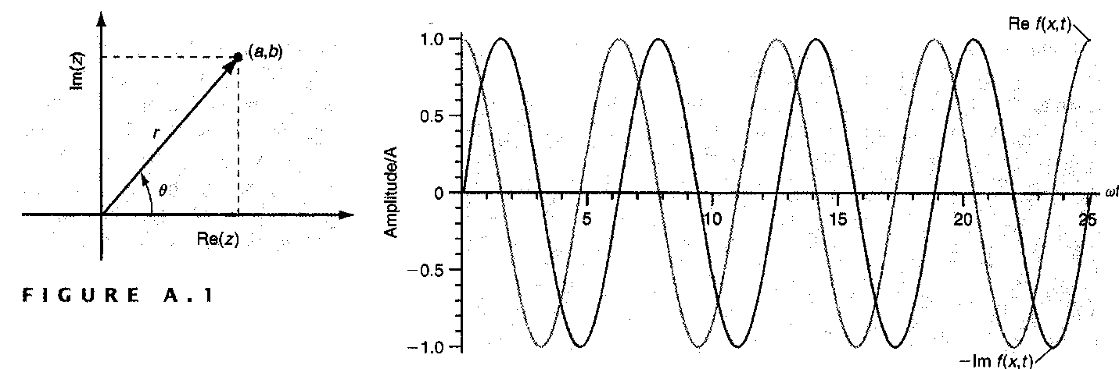

* Distance to the point **r** is the **magnitude** of the complex number: and the **angle (θ)** to the point wrt the x-axis is .
* Using these relations and Euler’s formula means that a complex number can be written in a number of different ways:

a + *i* b = r Cos θ + *i* r Sin θ = r ei θ = 

Thus, we can change the form of the representation.

Complex numbers can be added, multiplied and divided.

[Note ]

* The **complex conjugate** of a complex number z is denoted **z\*** where the **complex conjugate is obtained by substituting –*i* in z everywhere that *i* occurs**:
  + E.g., complex conjugate of x + *i* y is x – *i* y; complex conjugate of re*i*θ is re–*i*θ.
* The **magnitude** of a complex number z = x + *i*y is **always** a **real number** and is given by   where .

**Quantum Mechanical Waves and the Schrodinger Equation**

* We showed that a **classical standing wave** could be written as  which is a **product of 2 functions**: one depends solely on the **spatial coordinate (x)** and the other depends solely on **time coordinate (t)**. Substituting this function in the non-dispersive wave equation (p. 6) gives (eventually)  and using the relations ω = 2πν and νλ = v, (the velocity), we obtain



* We **“move” to QM by introducing the de Broglie relation (λ = h/p) and relating p to the total energy E and the potential energy, V(x),** via  [see earlier on p. 1] to obtain



or with  we obtain [Note: if  appears,  ≡ 1.05457181710–34 J s



* + These are expressions for the **Time-Independent Schrodinger Wave Equation (SWE)** in **1-D**.
  + **It is the fundamental equation used to study Stationary States of QM systems** (those are states for which the **values** of the measurable observables are **independent of time**, e.g., the 1s and 2s orbitals of the H atom).
  + The analogous **Time-Dependent SWE** **also** has **time** as a **variable** and takes the form



which is **used when the energy of the system changes with time**, e.g., when the energy of a molecule changes with the absorption of a photon.

* **These 2 equations form the basis of all QM calculations**: their **validity** has been **confirmed by numerous experiments**.
* The **meanings** to be attached to **“ψ(x)” and to “”** will be a focus of this course.
* Only one spatial coordinate has been included here to keep the notation simpler but these functions depend on all 3 spatial coordinates, which are x, y, z in Cartesian coordinates.
* Our main focus will be on the **stationary states** of a QM system. In this case, E and V have no time dependence.
  + Both the TD- and TI-SWE are satisfied in this case and the TD SWE simplifies to . [Note: in these notes, 
  + For **stationary states**, we saw that the wave function was dependent on the product of 2 functions, one depending on the spatial coordinates and the other depending on time:

 and substituting this in the above TD-SWE gives (after ψ(x) is cancelled from each side)

.

* Therefore, the **stationary state wave function** (= the **wave function** for a system whose **Energy is independent of time**) has the form:

 [Note: in these notes, 

* + This is **also the form of equation for a standing wave, i.e., stationary states in QM also correspond to standing waves**.

**Heisenberg Uncertainty Principle** – another concept different from what CP dictates

**CP:** We can **know** the **properties** of a body (or an “observable”) **to any desired level of accuracy** (e.g., x, v, and p at a given time) assuming that any disturbance made in performing the measurement can be made arbitrarily small.

**QM:** **Heisenberg** (1927) said that this **is NOT possible for particular pairs of observables** in QM’ical systems, i.e., values of **particular pairs of observables** **CANNOT be determined to any desired level of accuracy** or to an arbitrarily high level of precision.

* Such **complementary pairs** are **Position and Momentum** and **Energy and Time**.
*  (same applies to the other dimensions, y and z) and
*  where the Δ indicate uncertainties. [Note: in these notes, 
* We can understand the effects of HUP for the latter pair of observables in the following way:
  + Suppose an atom in an excited state emits a photon in going to a lower energy state;
    - if the excited atom has a **long, excited state lifetime** (i.e., long Δt), the HUP tells us that the **radiation emitted will be nearly monochromatic** (i.e., will have a small ΔE)
    - whereas if the **excited state lifetime is short** (i.e., small Δt), the radiation emitted will have a **wider spread in energy** (i.e., be of **wider bandwidth, a wider energy spread**).
* i.e., **Spectral lines** have a **“natural” bandwidth** determined by the **lifetime of the excited state**.
* Spectral lines **can be further broadened by collisions** (collisional broadening) **and by the Doppler effect** (due to the temperature). More about the latter effect later.
* These **uncertainties** are **inherent** **in QM** – they are **NOT** measurement uncertainties and because of this, the **results of QM calculations** are expressed as **probabilities**.

**Heisenberg** working independently also developed a successful approach to QM at the same time as Schrodinger did. We’ll use the Schrodinger approach and mostly focus on the **Time Independent SWE** because that suffices for most applications we will consider in chemistry.

* In each case, what was **introduced** for these theories (of Schrodinger and of Heisenberg) was a **series of concepts and postulates** (e.g., operators). These **are justified because they work in describing physical phenomena** and in **predicting new physical phenomena**.
* Some of these concepts will be hard to understand – in a sense you need to develop a new way of thinking.

**New Concepts in Solving the SWE (Schrodinger Wave Equation)** [Note: 

* Everything about a system can be determined from its **wavefunction ψ** (“Psi”) which is the **solution of the system’s wave equation** (i.e., of the SWE of the system).
* Saw that the SWE can be based on the classical wave equation provided we make a couple of “substitutions.” We also saw that a QM’ical wavefunction can be complex.
* Another way to “derive” the QM wave equation is to **substitute  for px** (and ) in the classical wave equation to obtain the TI SWE in 3-dimensions:  where the **operator** in brackets is called the ** operator** or the **Laplacian operator**. We mainly will limit discussion to the x-dimension for simplicity.

**Operators are used in QM:**

* To every measurable quantity (“**observable**”) such as energy, momentum or position, there is a corresponding **operator** in QM. QM operators often involve differentiation with respect to (wrt) a particular variable (e.g., position variable as shown above).
  + **Operators** are denoted by a **caret: $\hat{O}$.**
* An **operator** has a set of **eigenfunctions** and **eigenvalues** such that for a set of eigenfunctions **ψn**, there is a set of eigenvalues **an** so that

$\hat{O}$**ψn = an ψn (an eigenvalue equation);**

i.e., the operator $\hat{O}$“acting” on the wave function **ψn** “returns” the wave function **ψn** multiplied by an eigenvalue, **an**.

* **Eigenvalues** of QM operators are **always real numbers** because they correspond to the values of **observables** that are measured in an experiment (and these are real).
* In general, there are an infinite numbers of eigenfunctions for a given operator of a specific system.
* The **TI SWE is an eigenvalue equation**: [Note: 



where the section in [square brackets] is the **total energy operator**.

* This operator is abbreviated as and is called the **Hamiltonian** because of the similarity in format to the Hamiltonian in CP: **ψn = En ψn** .
* Note the **outcome of two or more sequential operators** can depend on the **order** in which the operations occur.

**Interpreting ψ**

* The **QM wave function** is interpreted to mean the **probability** of finding the particle of mass m between x & x + dx (ignoring other dimensions for simplicity) in the sense that this

**Probability is ψ(x)* ψ(x) dx** where ψ* is the complex conjugate of ψ . **How obtained?**

* Considered in terms of **Probability Density** we can say that the

**Probability Density = ψ(x)* ψ(x)**

(similar to expressing energy density by ρν or ρλ for Blackbody radiation).

* Since **ψ* ψ is a probability density,** it must be a **real number** (vs. an imaginary number) **and** it must be **positive**:

E.g., if ψ = a + *i*b then ψ* = a – *i*b so ψ* ψ = (a + *i*b)(a – *i*b) = a2 + b2 which is real and +ve.

* + Often write 
  + Extending the probability idea:

Probability (x1 ≤ x ≤ x2) = 

which is the probability of finding the particle in the region between x1 and x2

and since the particle must exist somewhere in space, we can state unequivocally

.

* Units of the wave function, ψ, are m–1/2 in 1-Dimension or m–3/2 for 3-Dimensions.
* This is the **Normalization condition**: for every wavefunction ψi,

.

Example of Normalizing a function [a(a-x)] is given in Example Problem 2.6 (2nd Ed.) or 2.7 (4th Ed.) of the Text.

* **Eigenfunctions** ψi and ψj of a QM operator (e.g., those associated with different vibrational energy levels) are usually **Orthogonal** i.e.,  where ψi and ψj corresponds to different eigenfunctions.
* **Orthogonality** is a concept we have encountered already: the 3 Cartesian coordinates are orthogonal: **x • y** = **x • z = y • z =** 0 where the dots represent the scalar products.
* **Orthonormal**: If wavefunctions are **normalized and are orthogonal** we say they form an **orthonormal set,** i.e.,  where  = the **Kronecker delta**. Wavefunctions ψ’s that satisfy this requirement are said to be **orthonormal**.
* In 3-D, this equation is  where

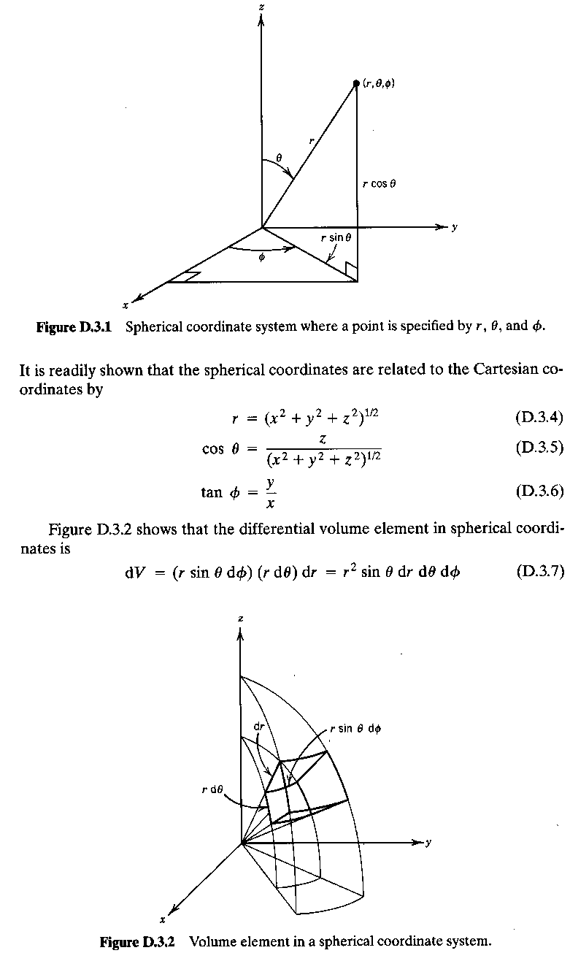

**dτ** (“Tau”) represents the **volume element**.

**Different Coordinate Systems**

* So far we have mostly considered ψ as a function of a single spatial dimension.
* Fine in many instances (such as in considering a harmonic oscillator).
* However, 3 dimensions are needed in many cases such as in considering atoms. These systems are **spherically symmetric** and a better system to use in describing such systems is the **Spherical coordinate (Sc) system r, θ, and φ** where the relationships between the 2 coordinate systems are:
  + x = r Sinθ Cosφ;
  + y = r Sinθ Sinφ;
  + z = r Cosθ. And the Cc
* Cc **volume element**, dτ = dx dy dz becomes
* Sc element, **dτ = r2 Sinθ dr dθ dφ** (very important) and the integration limits, which are −∞ to +∞ in Cc for each dimension become
* **Integral Limits** over All Space in Sc of:
* **0 ≤ θ ≤ π; 0 ≤ φ ≤ 2π; 0 ≤r ≤ ∞**

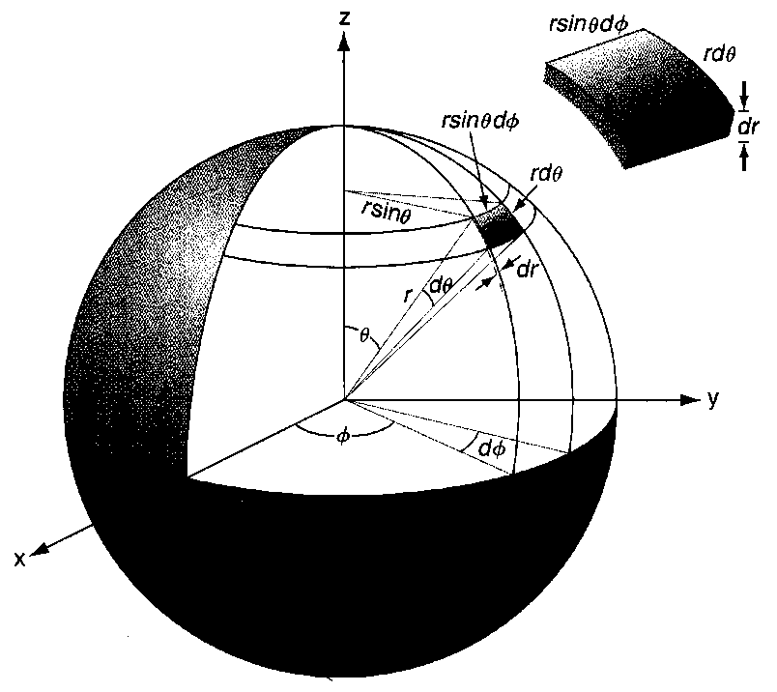

* **Wavefunctions** need to be **normalized** so they can be used in calculations.

**Will now do an example that illustrates how to normalize the wavefunction for an H atom in its ground state. Start with wavefunction (written in spherical coordinates):**

**ψ1 = N exp[–r/a0] where N is the normalization constant.** **You are given the definite integral** .

* **[**We should find that N = (πa03)–1/2 where a0 = Bohr radius = the “Atomic Unit” of Length = 5.29177210903 × 10–11 m. {More about Atomic Units later}].

**Completeness:**

* The eigenfunctions of any QM Operator form a ***Complete Set***.
  + E.g., in the Cartesian coordinate system, the unit vectors (**i**, **j**, **k**) form a complete set in the sense that any 3-Dimensional vector can be expressed as a linear combination of the unit vectors **i**, **j**, and **k**.
  + Thus, any “well-behaved” function, such as a wavefunction, f(x), can be expanded as a linear combination of the eigenfunctions (ψn) of any QM operator defined in the same space (which is x-dimension in our 1-Dal definition given below):

i.e.,  (≡ Definition of ***Completeness***)

**Class Normalization Exercise: Solution**

For a H atom in its ground state, we will find the wavefunction ψ1 (where the 1 subscript is used to denote the particular wavefunction) takes the form  where r = radius, a0 is the Bohr radius, N is the normalization constant and the wave function is written in spherical coordinates. **Determine N now.**

I.e., we need to find N in the following equation:



**Please note: it is necessary to include all 3 coordinates although the function only varies in r.** You are given.

**Solution:**

The integral over Theta, θ (colatitude) is



The integral over Phi, φ (azimuth) is



To determine the integral over r, we rely on the standard integral  where  and n = 2. This yields  for the integral over r:



Therefore, our result is  so 

Is  where A, n and a are constants an eigenfunction of operators (a) or of (b)?

**Solution:**

1. = x so the issue is whether ψ(x) = (constant) ψ(x) where the constant = the eigenvalue.

 ≠ (constant) ψ(x).

That is, ψ(x) is NOT an eigenfunction of the position operator.

1. ψ(x) =.

That is ψ(x) is NOT an eigenfunction of the linear momentum operator. It will be in the case of the Kinetic Energy operator, however.